**Exercise - Fusion with Multiple Radars**

**Task 1:**

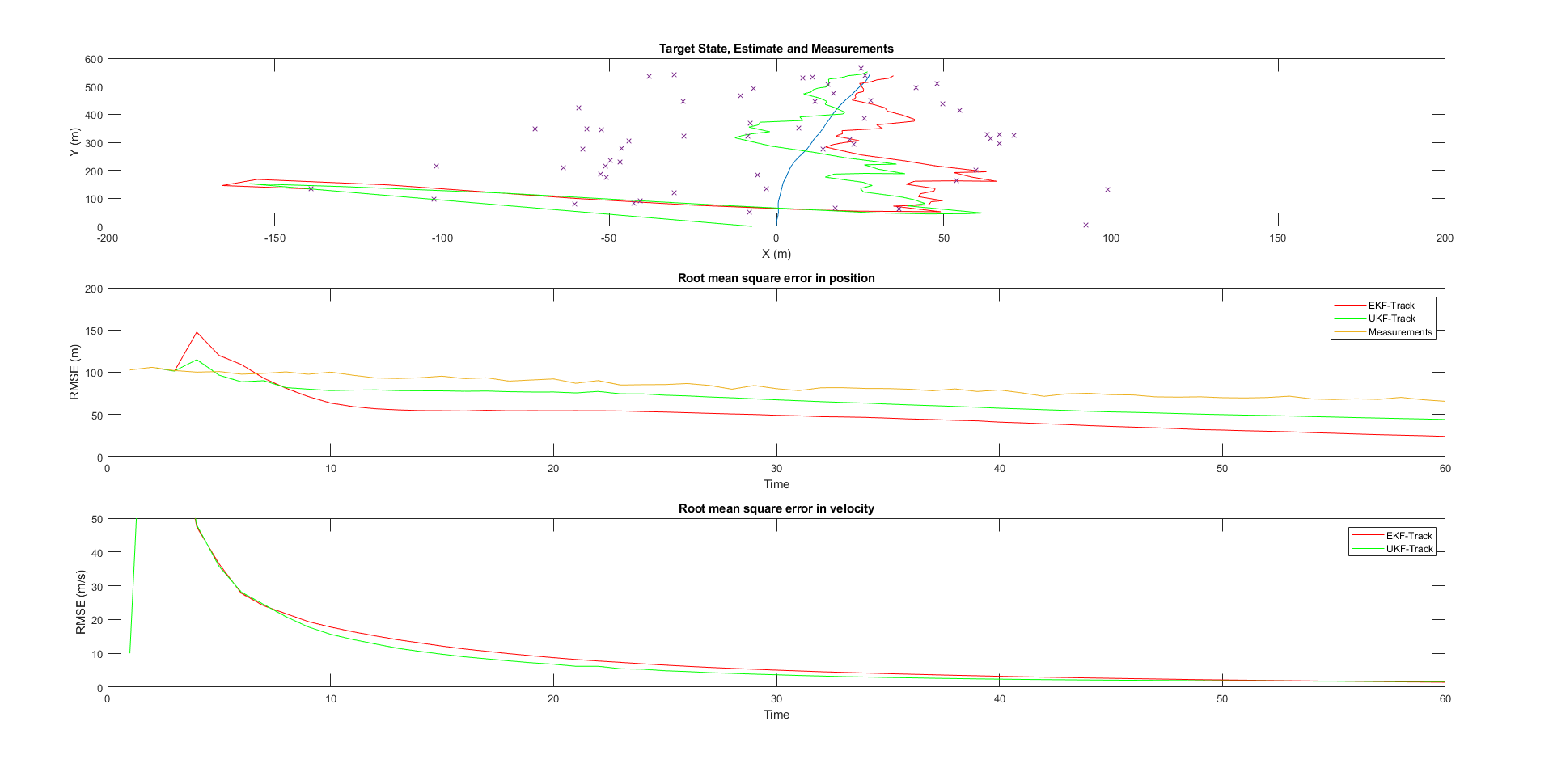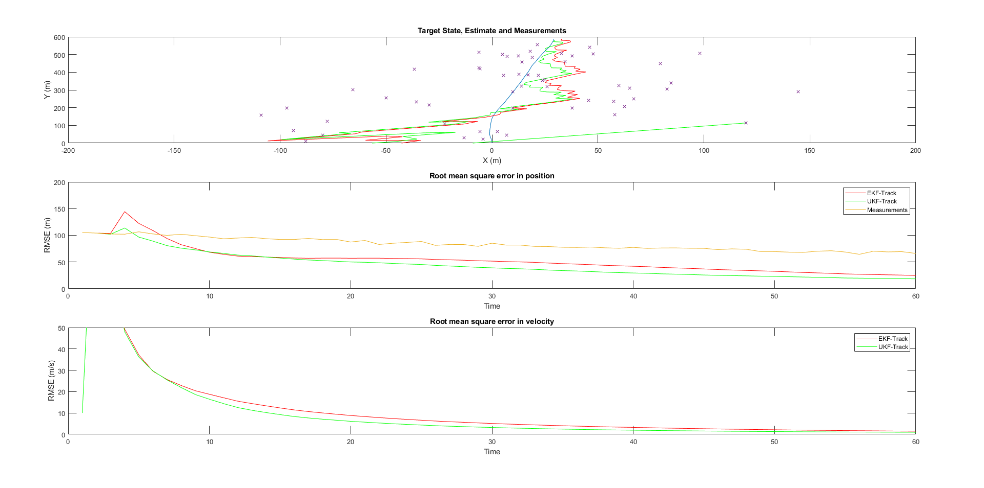

Radar at [600, 800]

Theta: 6 degrees

Radar at [-600, 800]

Theta: 6 degrees

**Task 2:**

**Fused Plots for Theta: 2, 4, 6 (in that order)**

